**Ashtanga Yoga**

1. **Sitting**
   1. **Bakasana**

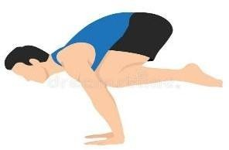

## ➤ Meaning:

* + - "Baka" means **crane** in Sanskrit. This pose mimics a crane standing still on its legs — symbolizing focus and balance.

## ➤ Technique:

1. Start in a squatting position with feet close together and hands on the floor, shoulder-width apart.
2. Bend your elbows slightly and place knees on the upper arms near the armpits.
3. Lean forward slowly, shifting weight onto your hands.
4. As you balance, lift one foot off the ground, then the other.
5. Keep the gaze forward (not down), and hold for a few breaths.
6. To exit, gently lower the feet back to the floor.

## ➤ Precautionary Measures:

* + Avoid if you have **wrist, shoulder, or elbow injuries**.
  + Warm up wrists and arms beforehand.
  + Practice on a cushioned surface to prevent injury in case of falling.

## ➤ Benefits:

* + Strengthens **arms, shoulders, and wrists**.
  + Improves **core strength and body balance**.
  + Enhances **concentration and confidence**.
  + Prepares body for advanced arm balances.

# Hanumanasana

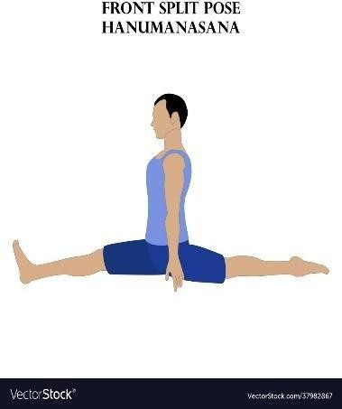

## ➤ Meaning:

* + - Named after **Lord Hanuman**, who made a great leap from India to Lanka — this asana symbolizes his leap and devotion.

## ➤ Technique:

1. Start in a kneeling lunge (right foot forward, left knee on the ground).
2. Slowly slide the front leg forward and the back leg backward along the floor.
3. Keep the pelvis squared and spine upright.
4. Place hands on the floor or raise arms overhead.
5. Hold the pose comfortably, then switch sides.

## ➤ Precautionary Measures:

* + Avoid if you have **hamstring or groin injuries**.
  + Don’t force the split — use blocks or cushions if needed.
  + Warm up with **hip openers and hamstring stretches**.

## ➤ Benefits:

* + Deeply stretches **hamstrings, thighs, and groins**.
  + Improves **hip flexibility and mobility**.
  + Tones pelvic muscles.
  + Encourages **patience, balance, and perseverance**.

# Ekapada Rajakapotasana

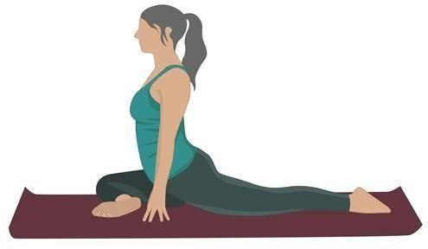

## ➤ Meaning:

* + - "Ekapada" = one leg, "Raja" = king, "Kapota" = pigeon. This is a royal pigeon pose performed with one leg forward.

## ➤ Technique:

1. Begin in a tabletop position.
2. Bring the right knee forward behind the right wrist, foot angled toward the left hip.
3. Extend the left leg straight back, top of the foot on the mat.
4. Keep hips squared and chest lifted.
5. For the advanced version, bend the back leg and hold the foot with both hands over the head.
6. Hold, breathe, and repeat on the other side.

## ➤ Precautionary Measures:

* + Avoid if you have **knee, hip, or lower back issues**.
  + Support the hip with a blanket if it doesn't touch the ground.
  + Do not strain the spine while lifting the chest.

## ➤ Benefits:

* + Opens **hips, thighs, and chest**.
  + Improves **posture and spinal flexibility**.
  + Stimulates abdominal organs.
  + Relieves **sciatic pain and lower back tension**.

# Yogamudra in Vajrasana

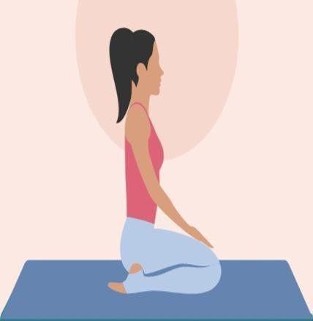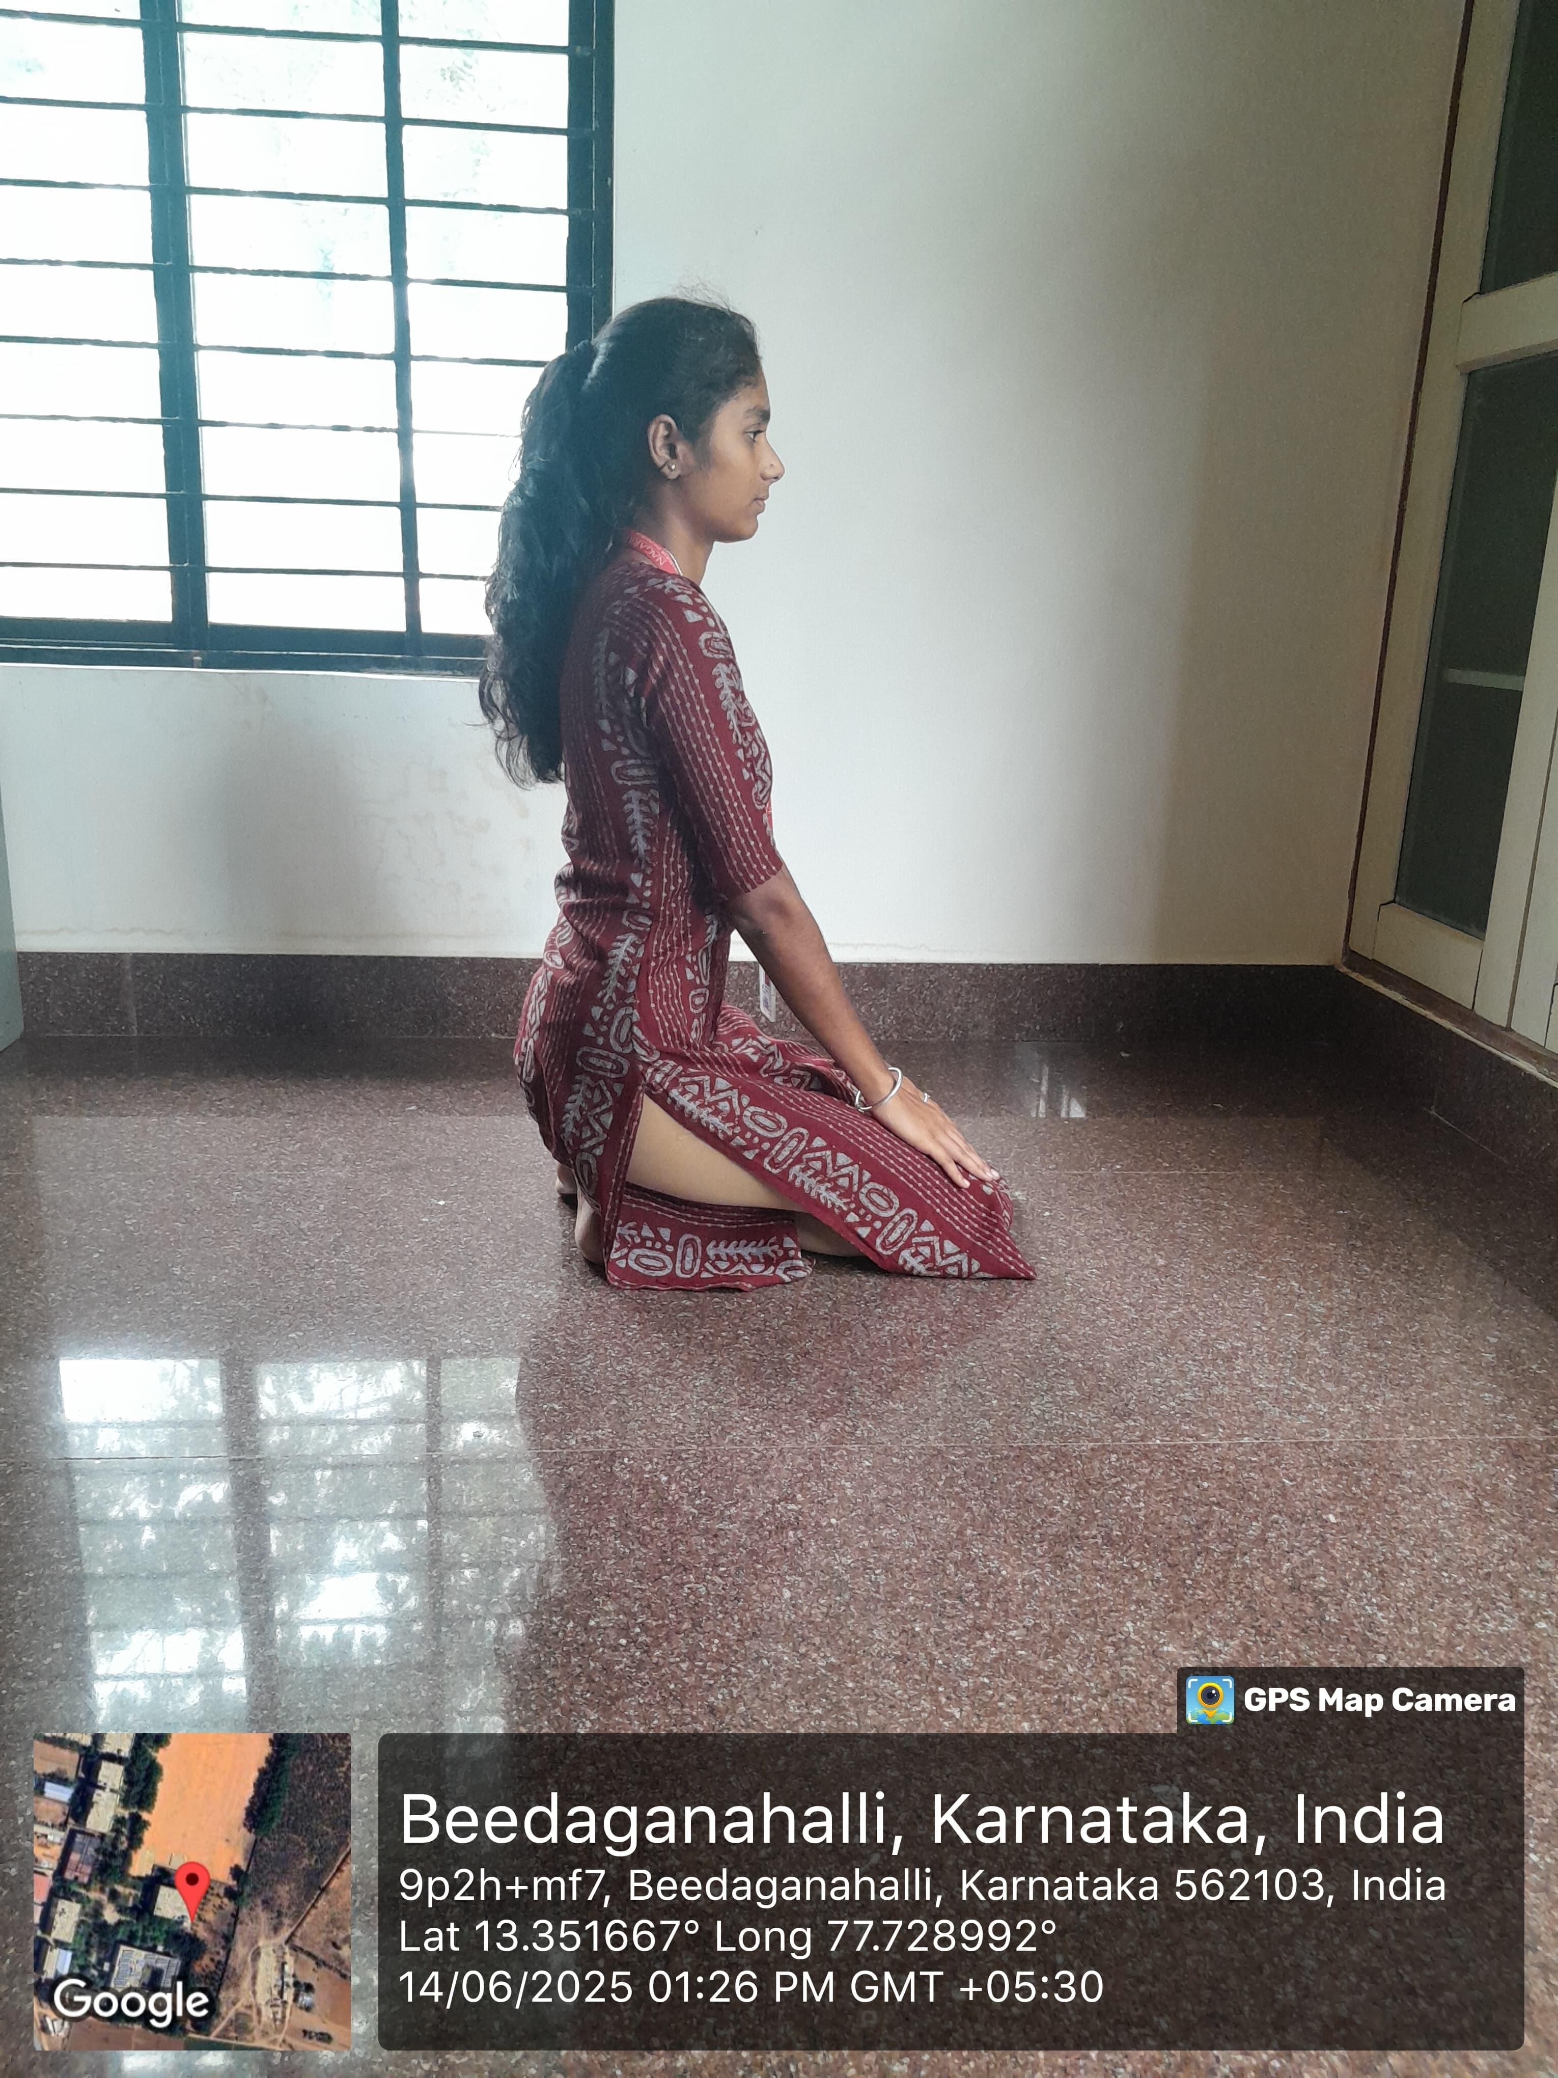

## ➤ Meaning:

* + - "Yoga Mudra" means **symbol/seal of yoga**; performed in **Vajrasana** (thunderbolt pose), it signifies surrender and internal focus.

## ➤ Technique:

1. Sit in **Vajrasana**: knees bent, sitting on the heels.
2. Clasp your hands behind your back or hold opposite wrists.
3. Inhale deeply, then exhale as you bend forward.
4. Bring the **forehead to the floor**, keeping your back straight.
5. Hold the posture and breathe slowly.
6. Inhale while returning to the upright position.

## ➤ Precautionary Measures:

* + Avoid if you have **knee injuries or severe back pain**.
  + Do not practice on a full stomach.
  + Pregnant women should avoid deep forward bending.

## ➤ Benefits:

* + Improves **digestion** and tones abdominal organs.

## Enhances spinal flexibility and circulation to the brain.

* + Calms the **nervous system** and reduces stress.
  + Aids in **developing humility and introspection**.

# Standing Asana

* 1. **Vatayanasana**

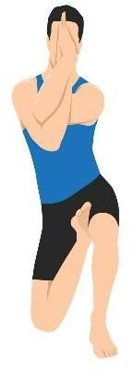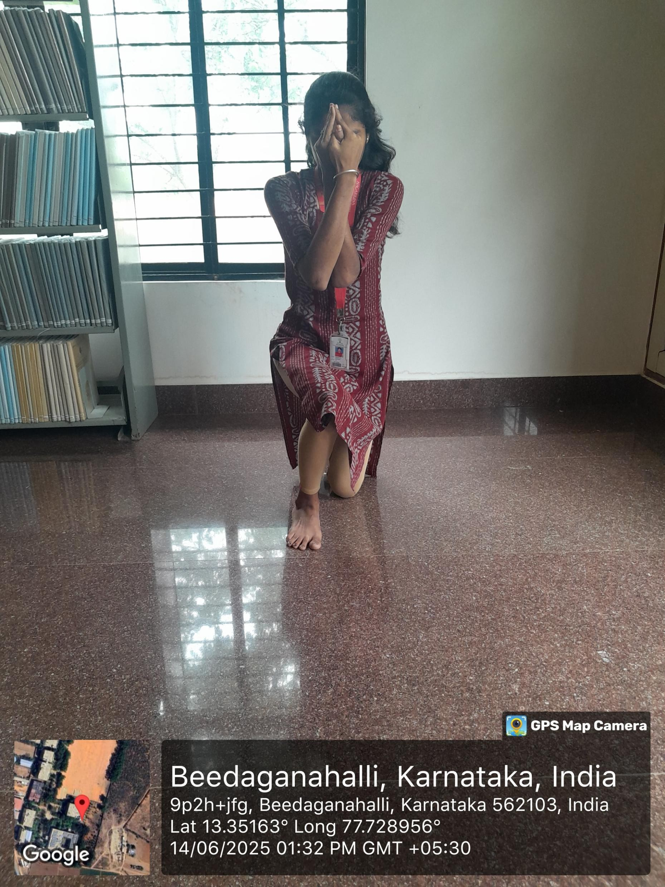

* + - "Vatayan" means horse. This asana resembles a horse rearing up.

## ➤ Technique:

1. Begin in a standing position (Tadasana).
2. Bend your right knee and place the foot on the inner thigh of the left leg (like in half-lotus).
3. Balance and bend your left knee slightly.
4. Bring your palms together in Namaste at the chest or above the head.
5. Hold, then switch sides.

## ➤ Precautionary Measures:

* + Avoid if you have hip, knee, or ankle injuries.
  + Not suitable for those with severe arthritis or balance disorders.

## ➤ Benefits:

* + Improves balance and flexibility of the hips and knees.
  + Strengthens legs and thighs.
  + Enhances body awareness and focus.

# Garudasana

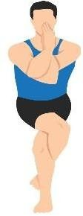

## ➤ Meaning:

* + "Garuda" means eagle. This pose symbolizes the strength and focus of an eagle.

## ➤ Technique:

1. Stand in Tadasana.
2. Bend the knees slightly and lift the right leg, wrapping it over the left thigh.
3. Wrap the right foot around the left calf if possible.
4. Cross the arms at the elbows, bringing palms together (right arm under the left).
5. Balance and hold the posture, then switch sides.

## ➤ Precautionary Measures:

* + Avoid if you have knee or shoulder injuries.
  + Use a wall for support if balance is an issue.

## ➤ Benefits:

* + Improves focus, balance, and concentration.
  + Strengthens legs and ankles.
  + Stretches shoulders, upper back, and thighs.

# Balancing

* 1. **Veerabhadrasana**

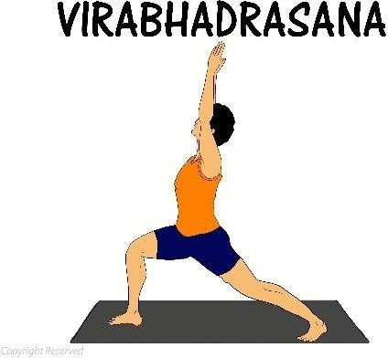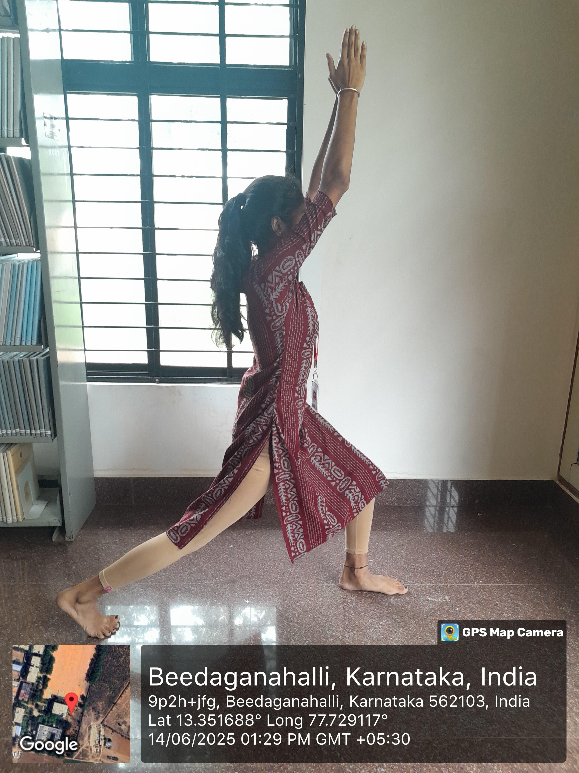

## ➤ Meaning:

* + Named after the fierce warrior Veerabhadra from Hindu mythology.

## ➤ Technique:

1. Stand in Tadasana and step your left foot back.
2. Bend the front knee (right) so it’s directly above the ankle.
3. Stretch both arms out parallel or raise them above the head.
4. Gaze forward and hold the pose, then switch legs.

## ➤ Precautionary Measures:

* + Avoid if you have knee or hip injuries.
  + Keep the back leg straight and avoid collapsing the front knee inward.

## ➤ Benefits:

* + Strengthens legs, arms, and back.
  + Increases stamina and endurance.
  + Opens the chest, lungs, and hips.
  + Boosts confidence and willpower.

# Sheershasana

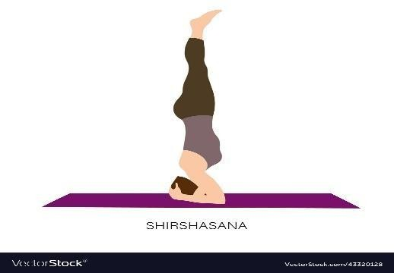

## ➤ Meaning:

* + "Sheersha" means head; this is the head-balancing pose, often called the "king of asanas."

## ➤ Technique:

1. Kneel on the floor and interlock your fingers to form a triangle base.
2. Place the crown of the head between your hands.
3. Slowly lift knees off the ground, walk the feet closer, and gently raise legs vertically.
4. Balance on the head and forearms, keeping the body straight.
5. Come down slowly, resting in child’s pose.

## ➤ Precautionary Measures:

* + Avoid if you have high blood pressure, neck problems, or eye disorders.
  + Practice under supervision initially.
  + Not recommended during menstruation or pregnancy.

## ➤ Benefits:

* + Improves blood flow to the brain.
  + Enhances memory, focus, and clarity.
  + Strengthens arms, shoulders, and spine.
  + Helps relieve stress and anxiety.

# Supine line

* 1. **Sarvangasana**

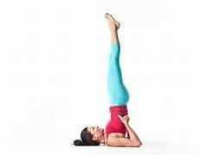

## ➤ Meaning:

* + "Sarvanga" means all limbs; this pose affects the entire body.

## ➤ Technique:

1. Lie on your back and lift your legs up to 90 degrees.
2. Support your back with your hands and raise your hips and torso vertically.
3. Keep your chin tucked into your chest.
4. Hold the pose and breathe gently.

## ➤ Precautionary Measures:

* + Avoid if you have neck issues, thyroid problems, or high blood pressure.
  + Come out slowly to avoid dizziness.

## ➤ Benefits:

* + Stimulates thyroid and improves metabolism.
  + Enhances blood circulation to the brain.
  + Strengthens back, shoulders, and core.
  + Calms the nervous system.

# Setubandha Sarvangasana

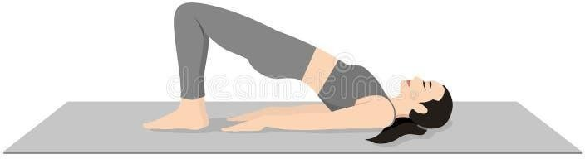

## ➤ Meaning:

* + - "Setu Bandha" means bridge formation; the body resembles a bridge in this posture.

## ➤ Technique:

1. Lie on your back with knees bent and feet hip-width apart.
2. Place arms beside the body, palms down.
3. Inhale and lift the hips up, pressing feet and shoulders into the mat.
4. Clasp hands under the back or support with palms.
5. Hold, then gently lower down.

## ➤ Precautionary Measures:

* + Avoid if you have neck or lower back injuries.
  + Use a block under the hips for support if needed.

## ➤ Benefits:

* + Strengthens lower back, glutes, and hamstrings.
  + Opens chest and shoulders.
  + Improves digestion and thyroid function.
  + Reduces anxiety and fatigue.

# Shavasana (Corpse Pose)

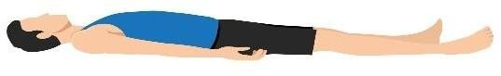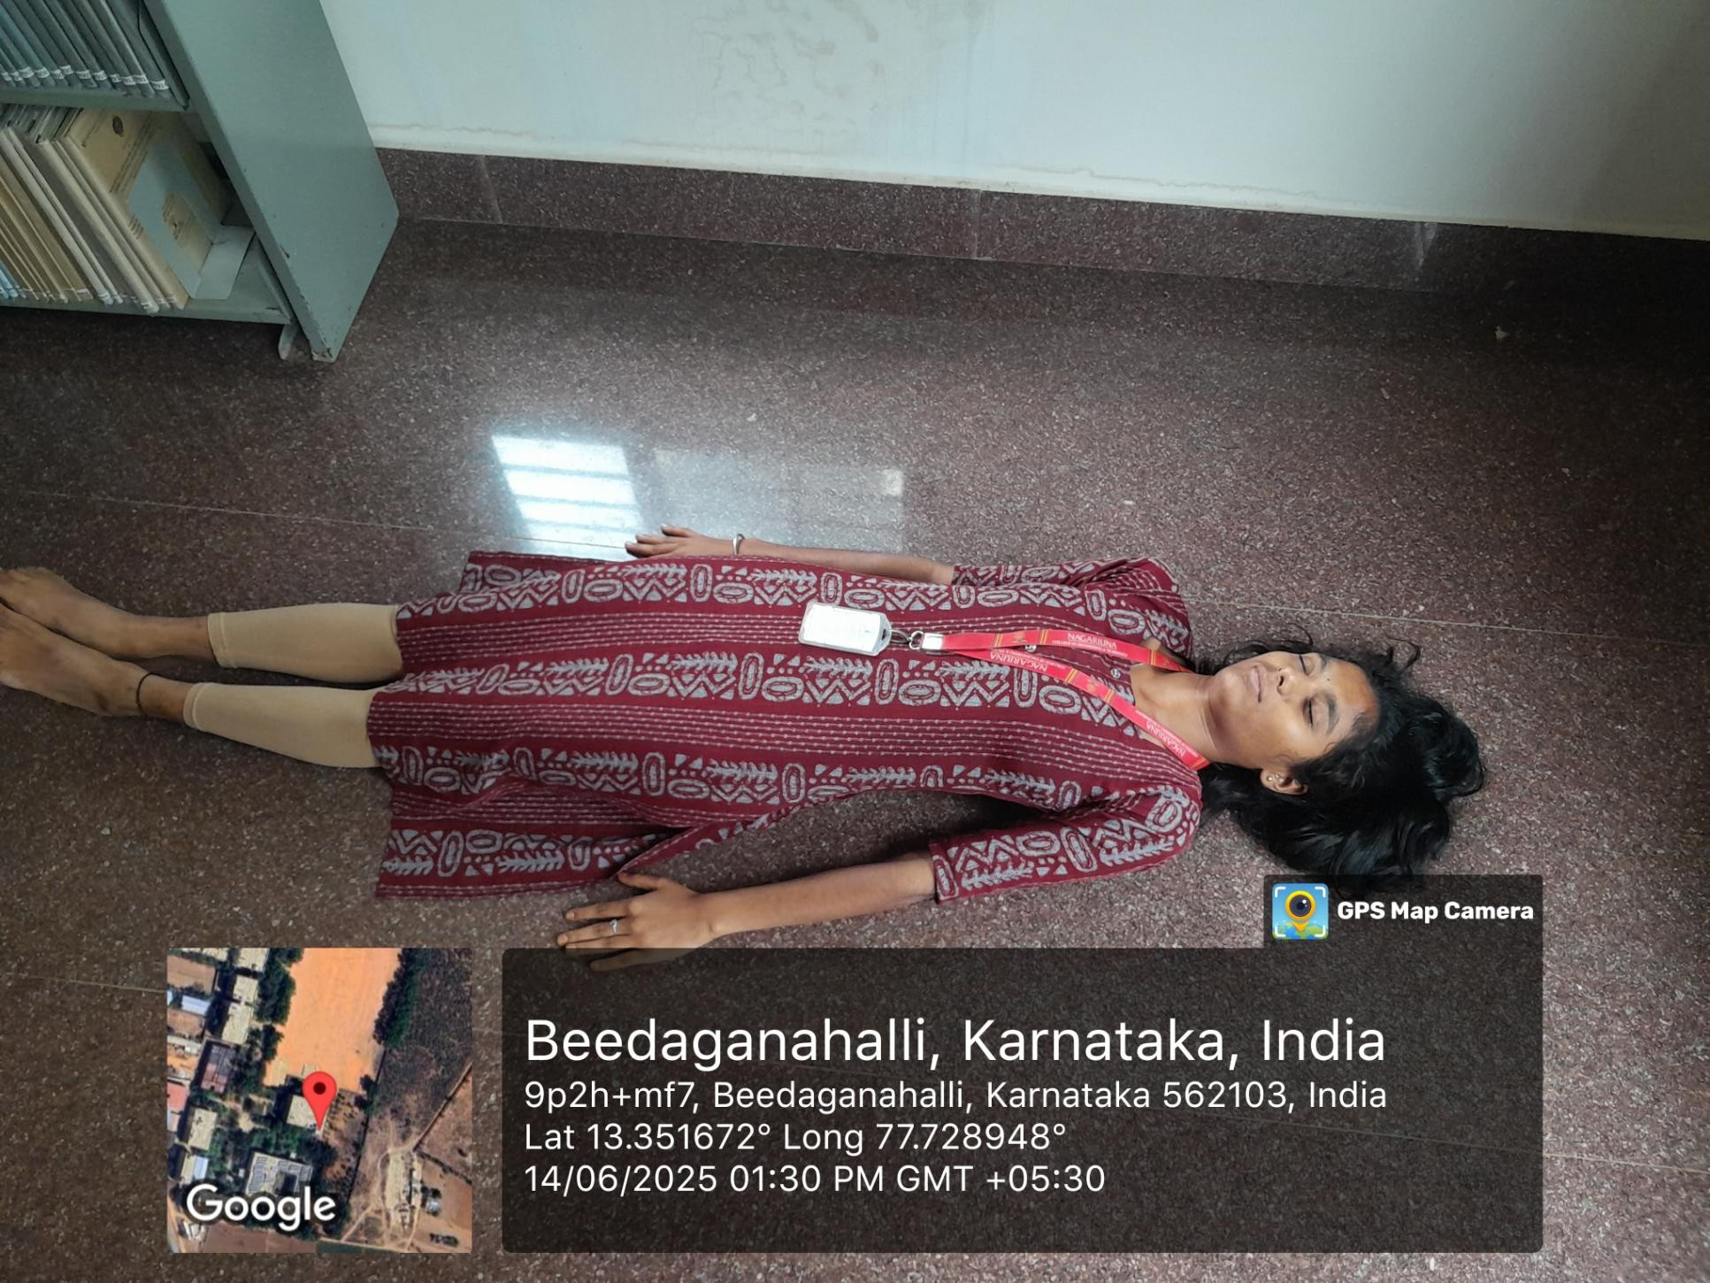

## ➤ Meaning:

* + "Shava" means corpse; this is a relaxation posture done at the end of practice.

## ➤ Technique:

1. Lie flat on your back with arms and legs slightly spread.
2. Close your eyes and relax the entire body.
3. Breathe normally and consciously release tension.
4. Stay in the pose for 5–10 minutes.

## ➤ Precautionary Measures:

* + Avoid sleeping in the pose.
  + Don’t move or fidget to maintain full relaxation.

## ➤ Benefits:

* + Deeply relaxes the body and mind.
  + Reduces stress and fatigue.
  + Helps absorb the benefits of yoga practice.
  + Improves emotional well-being and mindfulness.

Pranayama

1. Bhastrika Pranayama (Bellows Breath)

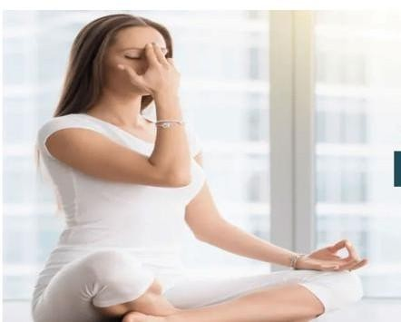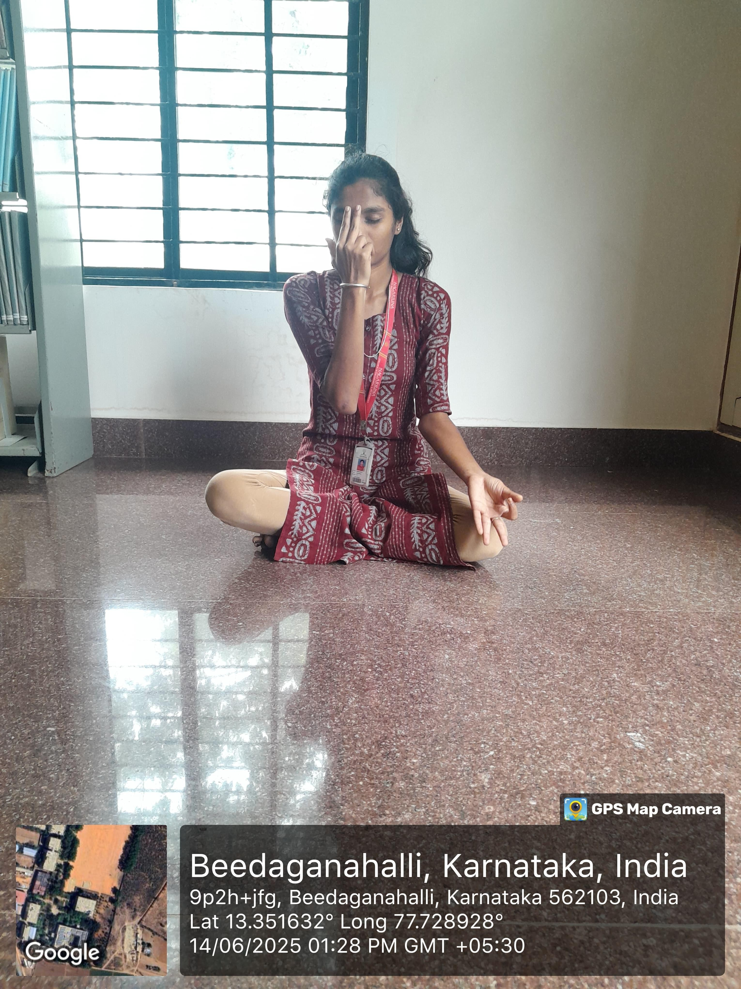

➤ Meaning:

* + “Bhastrika” means “bellows” in Sanskrit — like the bellows used to intensify a fire, this pranayama involves rapid inhalation and exhalation to stimulate energy and heat in the body.

➤ Technique:

Sit in a comfortable meditative posture with a straight spine. Take a deep breath in through the nose, expanding the lungs fully. Exhale forcefully through the nose using abdominal contractions.

Inhale and exhale with equal force — around 15–20 breaths per round.

After one round, take a deep breath, hold briefly (optional), then exhale slowly. Perform 2–3 rounds with short breaks in between.

➤ Precautionary Measures:

* + Avoid if you have high blood pressure, heart problems, hernia, or epilepsy.
  + Not suitable for pregnant women.
  + Perform on an empty stomach in a calm, ventilated space.
  + Beginners should learn under guidance.

➤ Benefits:

* + Increases lung capacity and energizes the body.
  + Clears respiratory tract and improves oxygen supply.
  + Boosts metabolism and enhances digestion.
  + Helps release stress, anxiety, and sluggishness.

1. Bhramari Pranayama (Humming Bee Breath)

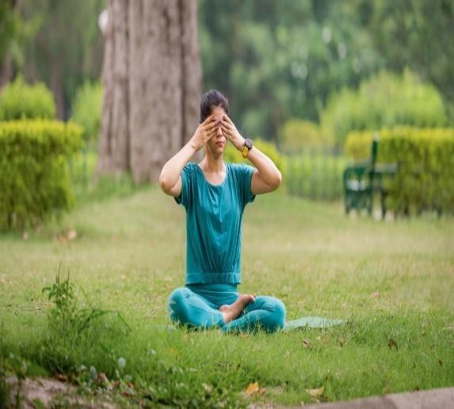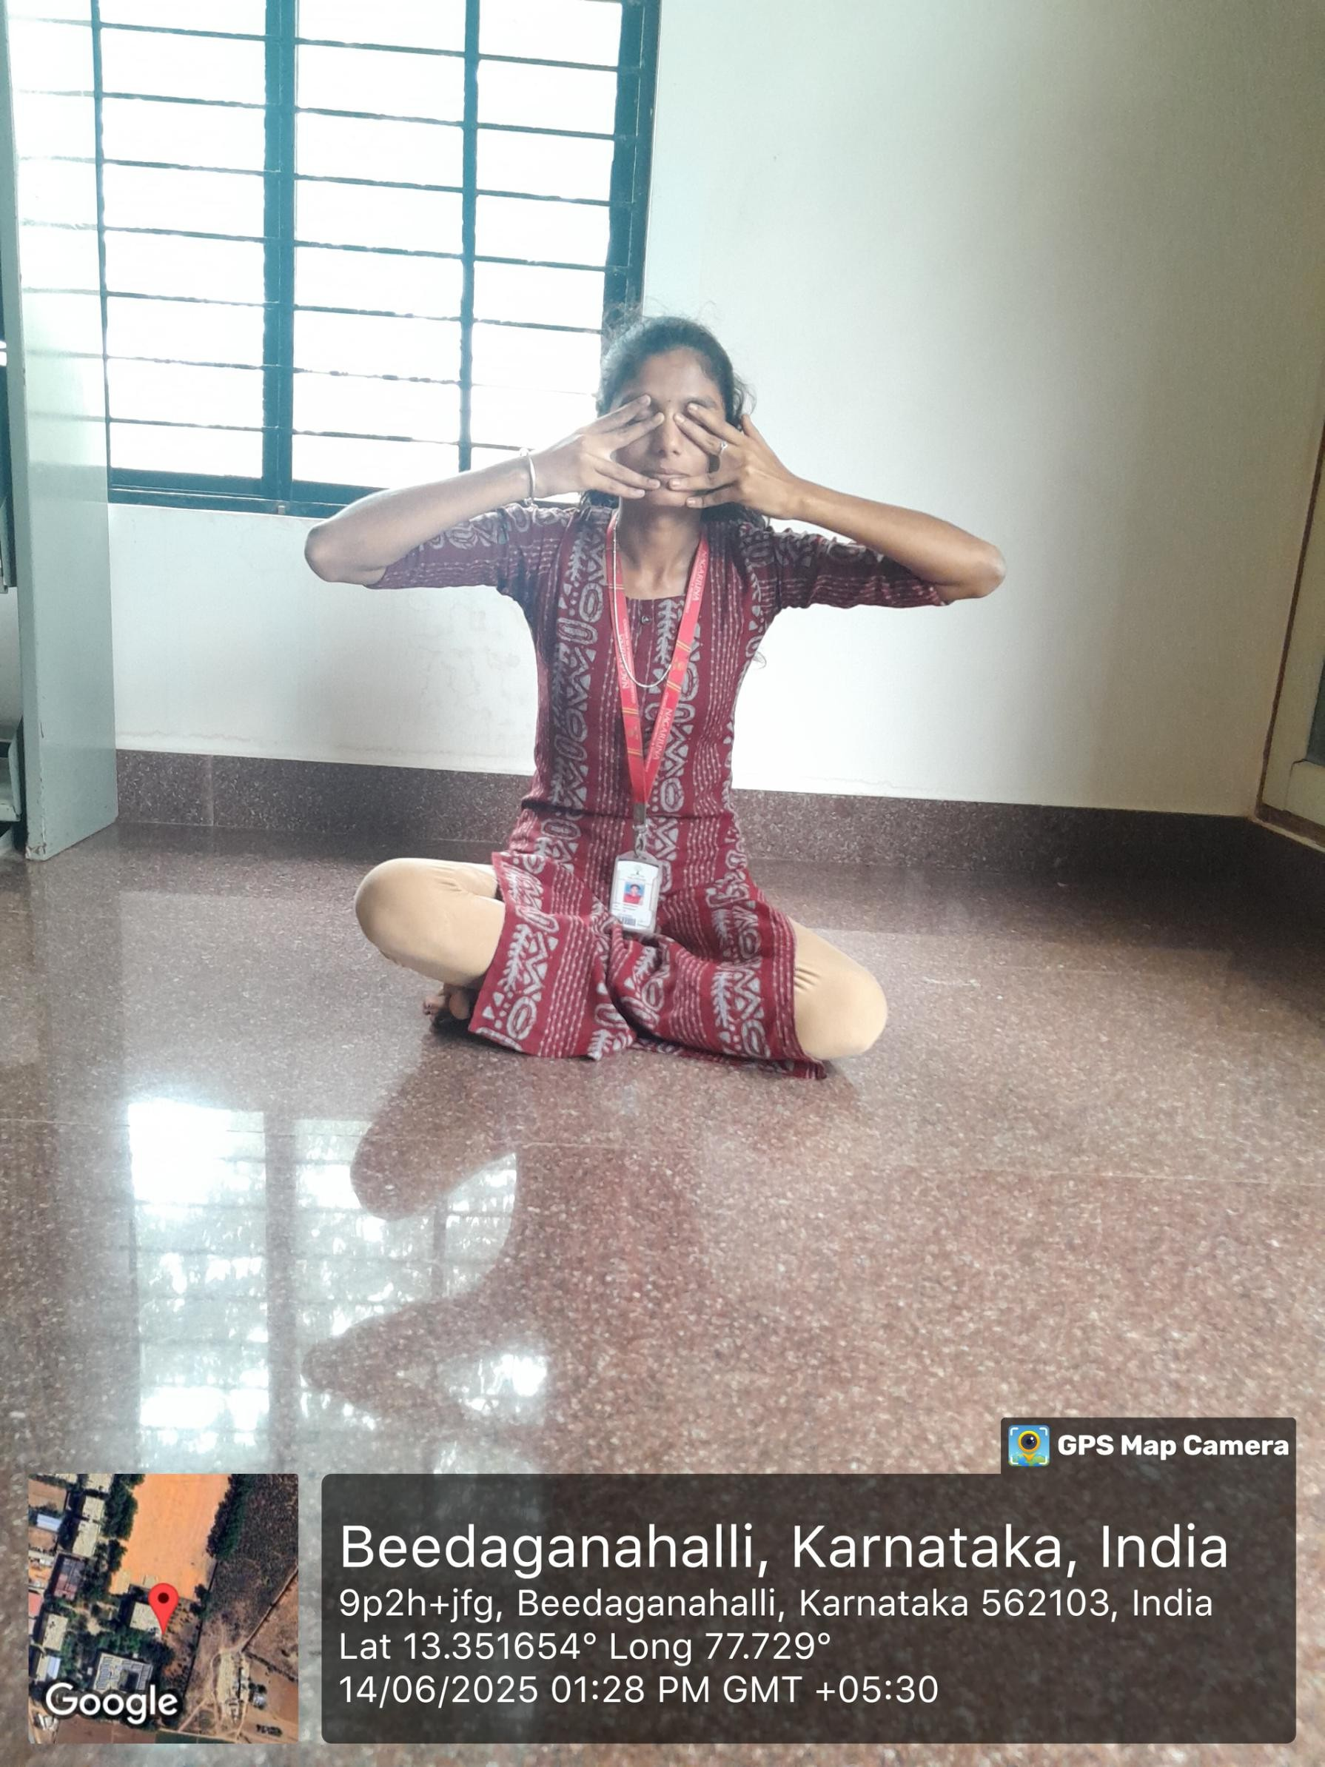

➤ Meaning:

* + “Bhramari” means “bee” in Sanskrit — named after the humming sound produced during exhalation, resembling a bee’s buzz, which calms and soothes the mind.

➤ Technique:

Sit comfortably with your eyes closed and spine straight.

Inhale deeply through the nose.

While exhaling slowly, produce a steady humming sound like “mmm” with lips closed. Focus on the vibration in the head and chest.

Repeat for 5–7 rounds.

➤ Precautionary Measures:

* + Avoid if suffering from severe ear infections or extreme sensitivity to sound.
  + Do not press the eyes too hard during Shanmukhi Mudra.
  + People with epilepsy or psychiatric conditions should consult a doctor.

➤ Benefits:

* + Instantly calms the mind and nervous system.
  + Reduces anger, stress, anxiety, and hypertension.
  + Improves memory, concentration, and emotional stability.
  + Helpful for insomnia, migraines, and mild depression.

Kriya

1. Jala Neti (Water Nasal Cleansing)

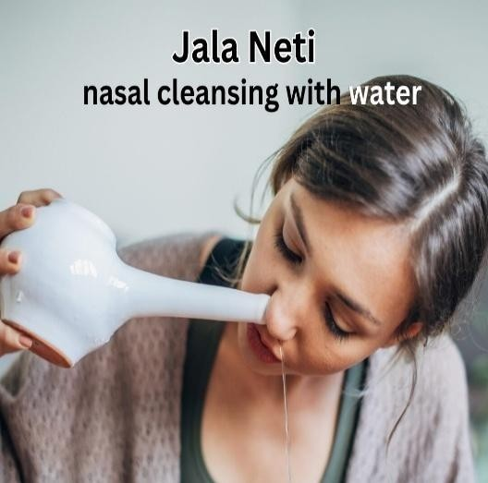

➤ Meaning by Name:

Jala = Water, Neti = Nasal cleansing Water-based nasal cleansing technique

➤ Technique:

* Use a Neti pot filled with lukewarm saline water (1 tsp salt in 500 ml).
* Tilt the head to one side over a sink.
* Insert the nozzle of the pot in the upper nostril, and let water flow out through the lower one.
* Breathe through the mouth.
* Repeat on the other side.
* Gently blow out any remaining water.

➤ Precautionary Measures:

* Use clean, sterilized water.
* Avoid if having severe cold, nasal injuries, or recent ear infections.
* Must be followed by **Kapalabhati** to dry the nostrils.

➤ Benefits:

* Clears nasal congestion, sinusitis, and allergies.
* Enhances breathing, especially helpful for asthmatics.
* Improves mental clarity and focus.
* Prevents common colds and improves eye health.

1. Sutra Neti (Thread Nasal Cleansing)

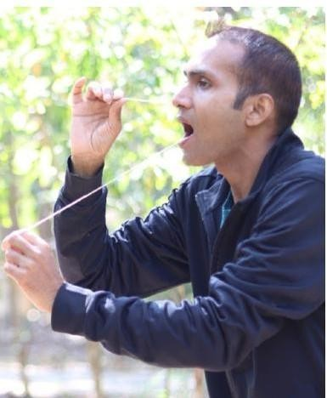

➤ Meaning by Name:

Sutra = Thread, Neti = Nasal cleansing Thread-based nasal cleaning technique

➤ Technique:

A thin rubber catheter or cotton thread (coated with wax) is inserted through one nostril. It is gently pushed back until it reaches the throat.

The end appearing in the throat is pulled out from the mouth. Move it back and forth slowly, then remove.

➤ Precautionary Measures:

* Should only be done under expert supervision.
* Not for children or beginners.
* Avoid if nasal passages are swollen or injured.

➤ **Benefits:**

* Deeper cleansing than Jala Neti.
* Removes deep-seated mucus and nasal polyps.
* Strengthens nasal passages.
* Enhances control over nasal and throat reflexes.

1. ​
2. ​
3. Nauli Kriya (Abdominal Churning – Only for Men)

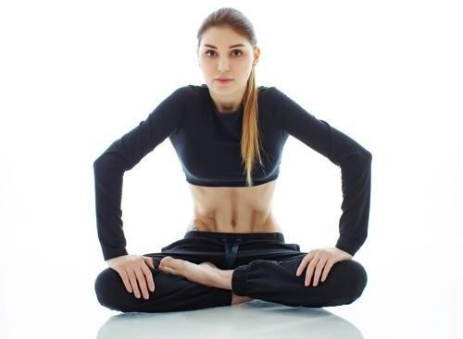

➤ Meaning by Name:

Nauli = To churn

⇒ Churning of abdominal muscles

➤ Technique:

* Stand with feet slightly apart.
* Inhale deeply, then exhale completely.
* Perform Uddiyana Bandha (pull abdomen in and up under the ribs).
* Isolate the rectus abdominis muscles and roll them side to side (churning motion).
* Perform clockwise and counter-clockwise movements.

➤ Precautionary Measures:

* Only for adult males; not suitable for women or children.
* Avoid if suffering from ulcers, hernia, high BP, or abdominal surgery. N v* Should be done on an empty stomach and only under guidance.

➤ Benefits:

* Massages and strengthens internal organs.
* Stimulates digestion and elimination.
* Balances endocrine and nervous systems.
* Removes gas, constipation, and strengthens core.

1. Sheetkarma Kapalabhati (Cooling Skull-Shining Breath)

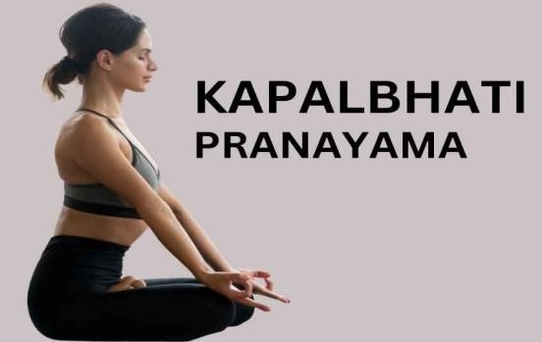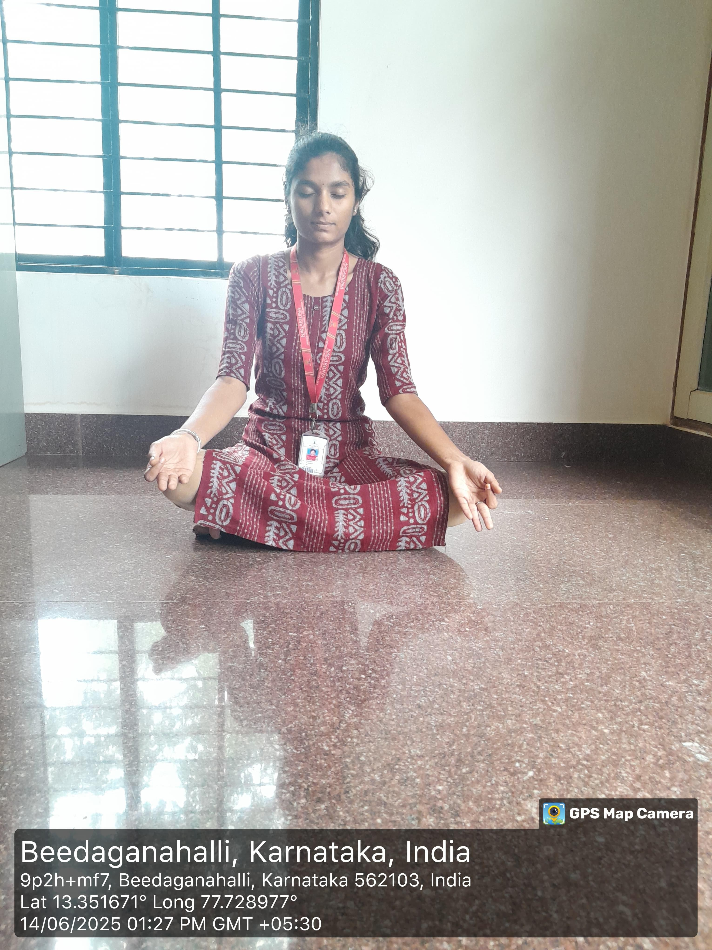

➤ Meaning by Name:

Sheet = Cool, Karma = Act, Kapal = Skull, Bhati = Shine Cooling act that purifies and energizes the brain

➤ Technique (Sheetkarma):

* Sit in a comfortable posture.
* Fold the tongue lengthwise and inhale air through the tongue (like sipping through a straw) – called Sheetali.
* Close the mouth and exhale through the nose.

➤ Technique (Kapalabhati):

* Sit upright with spine erect.
* Take a deep breath in.
* Exhale forcefully through the nose using abdominal contractions.
* Inhalation is passive; exhalation is active.
* Repeat for 30–50 strokes, rest, and perform 3 rounds.

➤Precautionary Measures:

Sheetkarma: Avoid in cold climates or if you have asthma. Kapalabhati: Avoid during pregnancy, menstruation, high BP, ulcers. Never overdo—start slow and increase with guidance.

➤ Benefits:

Sheetkarma: Cools the body, controls thirst and acidity, calms the mind.

Kapalabhati : Cleanses lungs and sinuses, enhances oxygenation, improves brain function, removes toxins, aids weight loss.